

MEDLEB

Booking System

Senior Project

By

**Ali Reda**

Submitted to the School of Arts & Science of the  Lebanese International University

In part of fulfillment of the requirements for the degree of

**BACHERLOR OF SCIENCE IN**

**COMPUTER SCIENCE AND INFORMATION TECHNOLOGY**

**Supervised by: Dr.Roummieh Youssef** Spring 2023-2024

# Dedication:

At the outset, we humbly dedicate this project to our divine Creator, whose boundless grace empowers us with strength and enlightenment for each day's journey.

To our beloved parents and cherished friends, whose unwavering encouragement and steadfast support have been the cornerstone of our academic and professional endeavors, nurturing our growth and fostering our aspirations.

Lastly, we express our profound gratitude to the esteemed Professor Youssef Roummieh, whose guidance and mentorship have been invaluable in navigating the challenges encountered throughout our project and our academic pursuits over the past three years.

## Acknowledgment:

Our "MEDLEB" project stands as a testament to our relentless dedication and tireless efforts. However, its timely completion and fulfillment of our vision wouldn't have been possible without the exceptional support and contributions from various individuals and organizations. We extend our heartfelt gratitude to each of them.

Foremost, we express our deepest appreciation to Professor Youssef Roummieh for his unwavering guidance, constant supervision, and invaluable insights throughout the duration of our project. His mentorship has been instrumental in shaping our endeavor.

We are also profoundly grateful to our parents and friends whose unwavering encouragement served as a constant source of motivation, enabling us to bring our project to fruition with precision and punctuality.

Their support has been indispensable, and we are truly grateful for their unwavering belief in our abilities.

## Abstract:

We are creating a hospital management system that allows patients to book appointments and to store data from our MedLeb website through internet.

The online Hospital system presents so many features for admins, patients, doctors and secretary. To explain more, the most important feature for our non-registered patient are to check illnesses related to the occurring symptoms. Moreover, only registered users are able to book appointments with desired doctors and view their medical records. However, for admins, they can add, delete and update Doctors . They can also view and delete patients. The doctors can add new patients , add/delete medical records, add/delete secretary and modify booked appointments. For the secretary they can modify appointments.

Throughout our proposal, we explain every single feature available in our website in details.

To sum up, the purpose of our hospital managment system is to provide a special service for patients so that they can get health care the most efficient way possible.

## List of Tables:

Table 1- login use case ................................................................................................................................ 18

Table 2 – Symptom Checker use case...........................................................................................................19

Table 3 – Register use case ......................................................................................................................... 20

Table 4 – Appointment booking use case ................................................................................................... 21

Table 5 – View Medical Records use case .................................................................................................. 22

Table 6 – Doctors Appointment use case .................................................................................................... 23 Table 7 – Add Patient Records use case ..................................................................................................... 24

Table 8 – Edit Doctor use case…….. .......................................................................................................... 25

List of Figures:

Figure 1- Use Case Diagram ....................................................................................................................... 15

Figure 2 - ER-Diagram ............................................................................................................................... 26 Figure 3 - Relational Diagram .................................................................................................................... 27

Figure 4 - Home Page Slider ....................................................................................................................... 29

Figure 5- slider .................................................................................................................... 30

Figure 6 - Trendy Products ........................................................................................................................ 31

Figure 7 – new feature ................................................................................................................. 31

Figure 8 - Appointments page....................................................................................................... 32

Figure 9 - Appointments page........................................................................................................ 32

Figure 10 – action buton - Explanation ............................................................................................. 32

Figure 11 – book appointment ..................................................................................................... 32

Figure 12 –doctor selection...................................................................................................................... 33

Figure 13 - date and time....................................................................................................... 33

Figure 14 – records page ................................................................................................................... 43

Figure 15 – download file view file......................................................................................................... 43

Figure 16 – symptom checker ...................................................................................................... 44

Figure 17 –symptom checker results................................................................................................ 44

Figure 19 –appointment card............................................................................................................ 45

Figure 18 – doctors cover ........................................................................................................................ 45

Figure 20 –time interval....................................................................................................................... 46

Figure 21 – view icons ................................................................................................................................ 46

Figure 23 – add appointment .................................................................................................... 47

Figure 22 – select name ...................................................................................................................... 47

Figure 24- select date and time ............................................................................................................. 48

Figure 28 – add records ....................................................................................................................... 49 Figure 27 – patient name ................................................................................................................... 49

Figure 26 – choose file ...................................................................................................................... 49

Figure 29 - settings ................................................................................................................................. 50

Figure 30 -assistant............................................................................................................................ 51

Figure 31 - patient ........................................................................................................................... 51

Figure 32 –admin profile.......................................................................................................................... 52

Figure 33 -assistance................................................................................................................... 53

Figure 34 –edit doctor..................................................................................................................... 54

Figure 35 – add/delete ............................................................................................................................ 54

Figure 36 -login.......................................................................................................................... 55

Figure 37 – sign up ............................................................................................................................ 56

Table of Contents:

Contents

Dedication II

Acknowledgment II

Abstract III

List of Tables IV

List of Images ………………… ………………………………………………………………… VI

Chapter 1 ..................................................................................................................................................... 11

1.1-Introduction: ......................................................................................................................................... 11

1.2-Objective:.............................................................................................................................................. 11

1.3-Scope: ................................................................................................................................................... 12

1.4-Technology Constraints: ....................................................................................................................... 12

**Software needed:** Visual studio code, Xampp, Web browser ................................................................... 12

1. 5-Problem:................................................................................................................................................ 13 1.6-Solution:................................................................................................................................................ 13 Chapter 2 .....................................................................................................................................................

14

1. 1-Functional and Conceptual Study ......................................................................................................... 14
   1. 1-Functional Requirements: .............................................................................................................. 14

2.1.2-Nonfunctional requirements: ......................................................................................................... 15 Security: .............................................................................................................................................. 15

Performance: ....................................................................................................................................... 15

Maintainability: ................................................................................................................................... 15

Reliability: ........................................................................................................................................... 15

2.2-UML Use Case Diagram & Scenario ............................................................................................... 16

* 1. 1-Use Case Diagram ..................................................................................................................... 16

2.2.2-Use Case scenarios (customer actor) ......................................................................................... 18

2.2.3-Use Case scenarios (Admin actor) ............................................................................................. 30

Chapter 3 ..................................................................................................................................................... 34

1. 1-System Design: ..................................................................................................................................... 34 3.1.1-ER-Diagram ................................................................................................................................... 34 ER Diagram Figure: ............................................................................................................................ 35

Relational Diagram Figure: ................................................................................................................. 36

Chapter 4

.....................................................................................................................................................

Implementation: .........................................................................................................................................

1. 1-Introduction: .....................................................................................................................................

4.2- Project’s Parts: .................................................................................................................................

4.2.1-Home Page: ................................................................................................................................

* + 1. appointments: ...................................................................................................................
    2. book appointment: ............................................................................................................
    3. records: ...............................................................................................................
    4. symptom checker: .....................................................................................................
    5. doctors page ....................................................................................................................

4.2.6-doctors add appointment:

...............................................................................................................................

4.2.7-add records: ..........................................................................................................................

4.2.8-doctors settings: .............................................................................................................................

* + 1. add assistante / patient:..............................................................................................
    2. admin page:........................................................................................................................
    3. Shoppiadmin add assistantg: ......................................................................
    4. Admin add doctor: ..............................................................................................
    5. Login/signup: .......................................................................................................................

Chapter 5 .....................................................................................................................................................

* 1. Conclusion: .......................................................................................................................................
  2. Future Work: ..................................................................................................................................... References ...............................................................................................................................................

Chapter 1

In this chapter, we are going to state the problem that we find, and how our project helps in solving it, in addition to mentioning technology constraints and our objective, then explaining all of them in details.

1.1-Introduction:

In today's dynamic world, the demands of modern life have reshaped traditional practices, including healthcare access. Long queues and hectic schedules often deter individuals from seeking medical attention promptly. Recognizing this, we introduce our Hospital Management System—a digital solution poised to revolutionize patient care. Rooted in electronic efficiency, our web-based platform simplifies healthcare delivery. Patients can seamlessly access services, book appointments, and review medical records from the comfort of their homes. As we delve into the system's features, we'll highlight its transformative benefits in enhancing healthcare accessibility and efficiency.

1.2-Objective:

The primary objective of our platform for our Hospital Management System project is to streamline and enhance the healthcare experience for both patients and medical practitioners. By leveraging digital solutions, we aim to eliminate the various challenges associated with traditional healthcare delivery methods. Our system endeavors to broaden access to medical services, transcending the constraints of physical space, time, and location. Moreover, it seeks to optimize operational efficiency within healthcare facilities while prioritizing patient satisfaction and care quality.

1.3-Scope:

This system outlines the modeling and requirement analysis for our Hospital Management System, with the objective of addressing the challenges inherent in traditional healthcare facilities. It offers a versatile solution applicable to local clinics as well as multinational healthcare chains with multiple outlets. The system proposes features such as round-the-clock order acceptance and a home delivery service, designed to enhance customer satisfaction. By providing an online portal for patients to access healthcare services conveniently from anywhere, healthcare facilities can effectively compete with emerging digital healthcare platforms, ensuring they retain their customer base and adapt to evolving consumer preferences.

1.4-Technology Constraints:

**Software needed:** Visual studio code, Xampp, Web browser

**Languages:** php, javascript, html, css, mysql **Frameworks & libraries:** bootstarp , ajax.

**Hardware:** laptop.

1.5-Problem:

Traditional healthcare systems are fraught with numerous challenges:

* Patients often endure the inconvenience of traveling to healthcare facilities, incurring transportation costs in the process.

* Many healthcare facilities operate within restricted daytime hours, making it difficult for individuals with work or other commitments to access medical care.

* Healthcare services offered through traditional channels are often associated with high costs, placing financial strain on patients.

* The crowded and bustling environment of healthcare facilities can detract from the overall patient experience, diminishing comfort and satisfaction.

1.6-Solution:

Introducing a comprehensive Hospital Management System that addresses these challenges by:

* Facilitating online appointment booking and medical record access.
* Providing a user-friendly interface for patients to navigate and find relevant healthcare services effortlessly.

* Mitigating the risk of exposure to crowded healthcare facilities, particularly amidst the current COVID-19 pandemic.

* Streamlining healthcare processes to optimize time and cost savings for patients.

* Expanding the range of healthcare services available to patients, ensuring comprehensive care options.

* Enhancing patient satisfaction through personalized and efficient healthcare delivery.

Chapter 2

This chapter describes both functional and non-functional requirements for our project. In addition to that it shows the UML use cases and scenarios with all related details.

2.1-Functional and Conceptual Study

2.1.1-Functional Requirements:

* + 1. **Sign up:** Every person can view the system but only registered people who have an account can access the appointment booking and medical records.
    2. **View appointments**:patients must be able to view their booked appointments.
    3. **Symptom checker:** the patient can enter a set of symptoms and the system will predict the illnesses with a percentage
    4. **Login:** The system allows customers to login easily to view their appointments.
    5. **Medical Record Access:** Patients should have access to view their medical records, including test results, prescriptions, and treatment histories. Doctors should be able to add, update, and review patient medical records.

2.1.2-Nonfunctional requirements:

Security:

* Login: Any users who make use of the system needs to hold a Login email and password.

Performance:

* 1. Fast Response Time for User Login (The average response time for user login after entering email and password should be no more than 3 secs and the maximum response time should be 10 seconds),
  2. Fast Average Time for Rendering a Page (After clicking on any link the result should be rendered within no more than 1 second in average and it should not take more than 10 seconds in maximum),
  3. Minimum number of concurrent users: The website should be able to address at least 1000 users concurrently.

Maintainability:

* Errors: The system will track every mistake. Reliability:

* Availability: The system is available all the time (24*7 available).

1. 2-UML Use Case Diagram & Scenario

2.2.1-Use Case Diagram

For the Hospital Management System, user interactions are designed to meet the needs of patients and administrators alike. The primary user interactions, or top-level use cases, include Browse, Login, Search, Book Appointment, View Medical Records.

Additionally, functionalities such as checkout, viewing appointment details, modifying appointments, and logging out are part of extended use cases accessible within the main use cases.

For administrators, there are distinct use cases tailored to their roles. These include managing patients, doctors, appointments, staff, and system configuration. Administrators can also view reports and analytics to monitor system performance and user engagement.

These use cases collectively form the foundation of the Hospital Management System, catering to the needs of both patients and administrators.

(see figure 1)

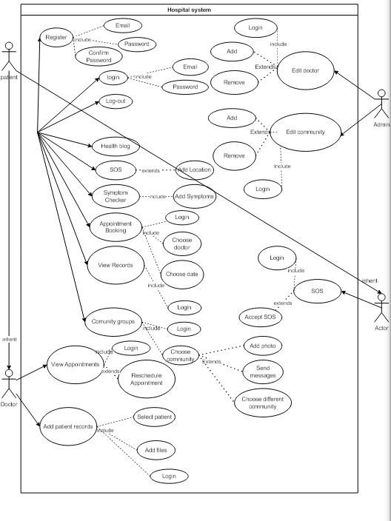

*Figure* *1- Use Case Diagram*

2.2.2-Use Case scenarios

In this part we will be explaining all of the mentioned use cases in details, regarding primary actors, main flow, and the alternative one. In addition to a short description for each use case making all points clear.

*Login use case*

Check table 1 – login use case scenario to see related details regarding login use case.

*Table 1- login use case*

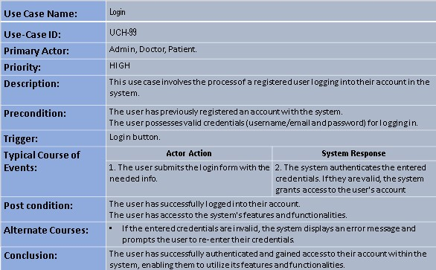

*Symptom checker*

For more details about symptom checker use case, see table 2 – symptom checker use case scenario

*Table 2 – symptom checker*

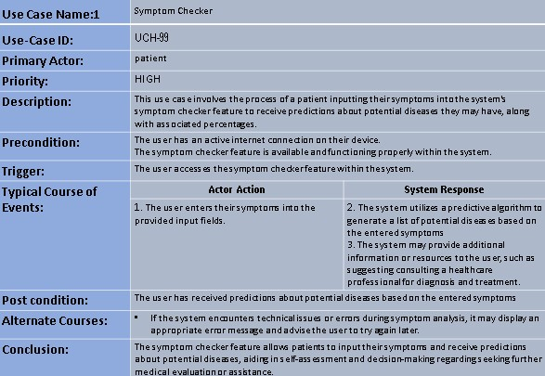

*register*

See table 3 – registeruse case scenario, to check all details related to this case from the actors, to main and alternative flow, and so on.

*Table 3 – register*

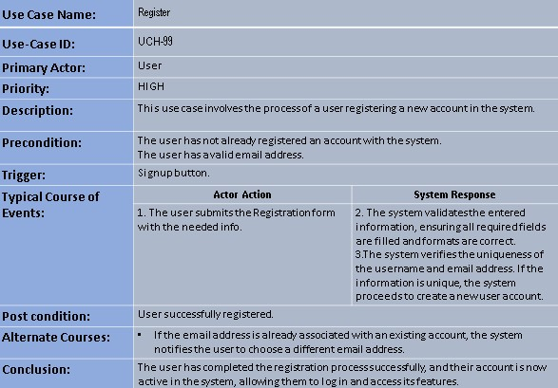

*Appointment booking*

For more details regarding appointment booking use case, see table 4 – appointment booking use case scenario.

*Table 4 – appointment booking*

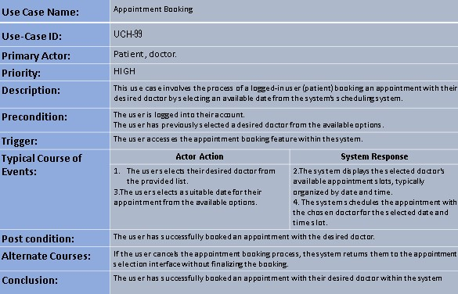

*View medical records*

See table 5 – view medical records use case scenario to check information related to primary and secondary actors, in addition to brief description of the use case and its flow.

*Table 5 – view medical records*

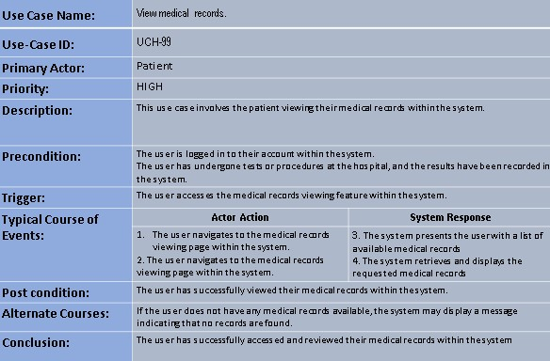

*Doctors appointment*

See table 6 – doctors appointment use case scenario to check information related to primary and secondary actors, in addition to brief description of doctors appointment use case and its flow.

*Table 6 – doctors appointment*

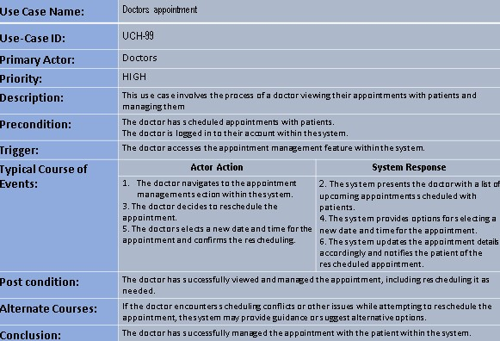

*Add patient records*

See table 7 – add patient records use case scenario to check information related to primary and secondary actors, in addition to brief description of add patient use case and its flow.

*Table 7 – add patient records*

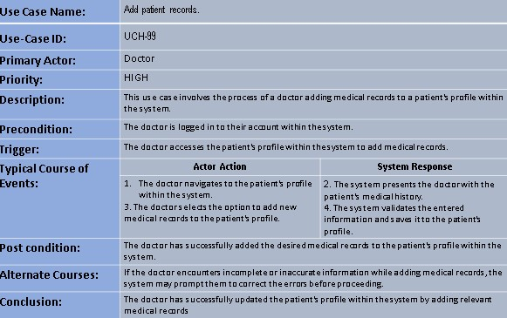

*Edit doctor*

See table 8 – edit doctor use case scenario to check information related to primary and secondary actors, in addition to brief description of edit doctor use case and its flow.

*Table 8 – Edit doctor*

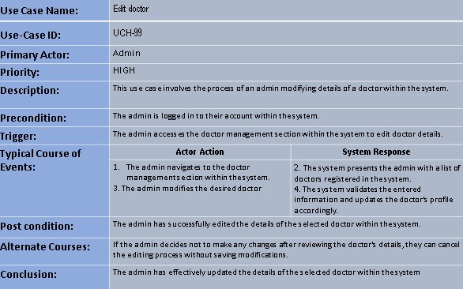

Chapter 3

This chapter describes the system design, including the data base of our project, the related tables and the relations between them.

1. 1-System Design:

3.1.1-ER-Diagram

This ER (Entity Relationship) Diagram represents the model of the hospital management system.

It shows all the instruments of database tables and the relations between them.(see figure 2)

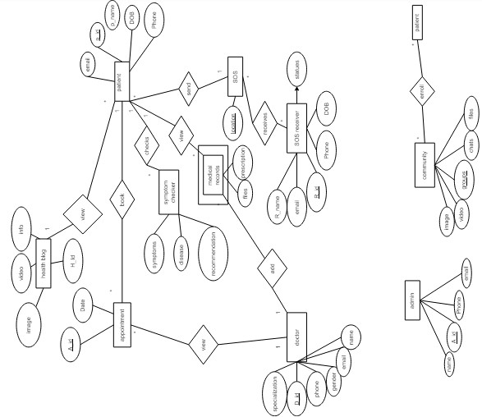

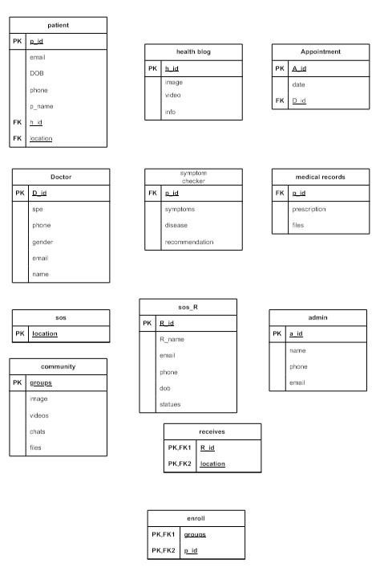

*Figure 2 - ER-Diagram*

Relational Diagram Figure:

See figure 3 – Relational Diagram to see all the attributes of each entity, in addition to the relations between entities.

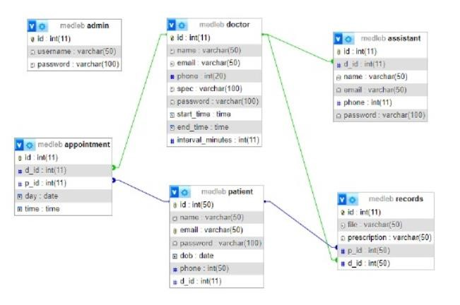

*Figure 3* *- Relational Diagram*

Chapter 4

This chapter describes the whole view of our website, it shows the design our projects in addition to stating the main role of each page or button.

Implementation:

1. 1-Introduction:

The implementation of our Hospital Management System demonstrates the interface design and functionality aimed at ensuring optimal performance and service for all users. Our goal is to create a user-friendly interface suitable for individuals of all ages. We have prioritized simplicity and comfort for the user, striving to make navigation seamless and visually pleasing.

Upon accessing our website, users will find a straightforward interface that allows for easy navigation from page to page without encountering any challenges or interruptions. Below, we will outline the various pages of our system and provide detailed insights into their design and functionality.

* 1. Project’s Parts:

4.2.1-Home Page:

Our home page is the first page that appears after visiting our website. See figure 4

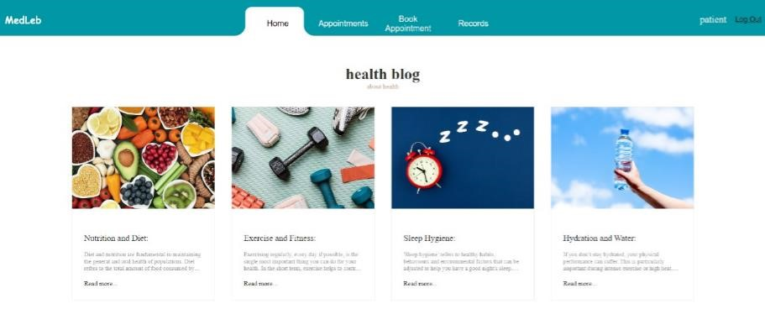

*Figure* *4 - Home Page Slider*

This slider contains basic virus protection info. Figure 5- slider



*Figure* *5- slider*

Here the user can click on read more and it will redirect to a page for more info on the topic. (see figure 6)



*Figure*  *6 - Trendy Products*

In this part, there is a feature for our website if clicked on link you will access it. (see figure 7)

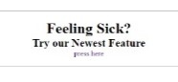

*Figure 7 - New feature*

* + 1. Appointments:

Here is the patients Appointments page where the patient can view the appointment he has booked and can message with secretary whenever cancel button is pressed . Figure 9 - New Arrivals Page **&** Figure 10 - New Arrivals page - Explanation

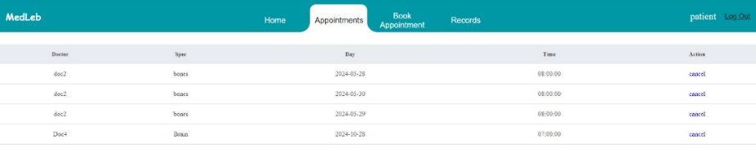

*Figure 9 – Appointments Page*

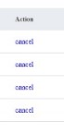

*Figure*  *10 – Action button - Explanation*

* + 1. book appointment:

In this page,patient can book an appointment by selecting the desired doctor profession the desired doctor the date and time . ( Figure 11 – Book appointment page **&** Figure 12 – Doctor selection **&** Figure 13 – date and time )

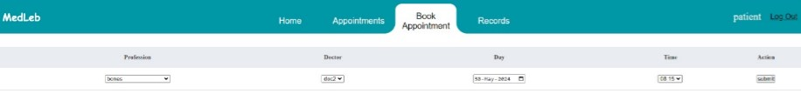

*Figure 11 – book appointment*

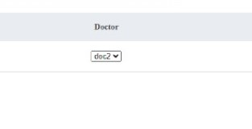

*Figure 12 – doctor selection*

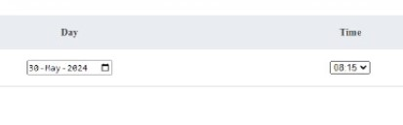

*Figure 13 – date and time*

* + 1. records:

In this page,patient can view their medical records and download them by clicking on “download File

View file” (Figure 14 – Records page **&** Figure 15 – Download file View file )

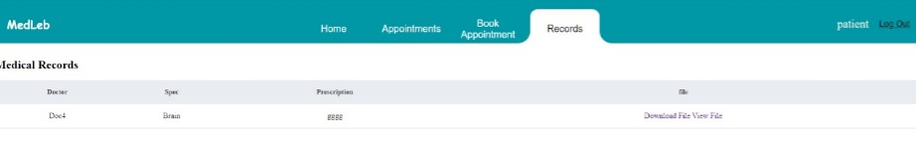

*Figure 14 – records page*

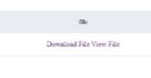

*Figure 15 – Download file View File*

* + 1. symptom checker:

In this page ,patients can use this system to see the illnesses they may have by selecting showing symptoms and the system will predict an illness based on the symptoms. (Figure 16 – Symptom checker**&** Figure 17 – Symptom checker results )

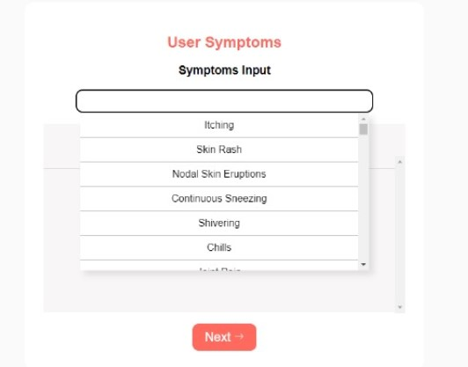

*Figure 16 – Symptom checker*

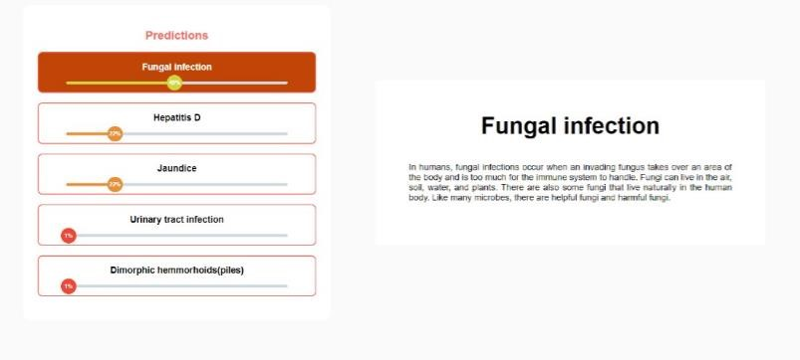

*Figure 17 – Symptom checker results*

* + 1. doctors page:

In this page, Doctors can View the appointments patients have booked they can set the start and finish of their shift and the time an appointment would take the view can chang e by clicking on the top right icon the doctor can delete an appointment or postpone it(Figure 18 – Doctors cover **&** Figure 20 – time interval **&** Figure 19 – appointments card **&** Figure 21 - Shoes Kids)

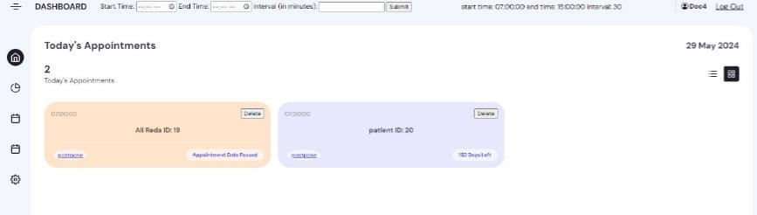

*Figure 18 – Doctors cover*

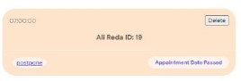

*Figure 19 – appointment card*



*Figure 20 – time interval*

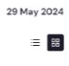

*Figure 21 – view icons*

4.2.6- doctors add appointmnent:

In this page, Doctors can add appointments for patients by selecting the patient and the date and time(Figure 23 – add apointment**&** Figure 22 – patient selector **&** Figure 24- date and time selector **)**

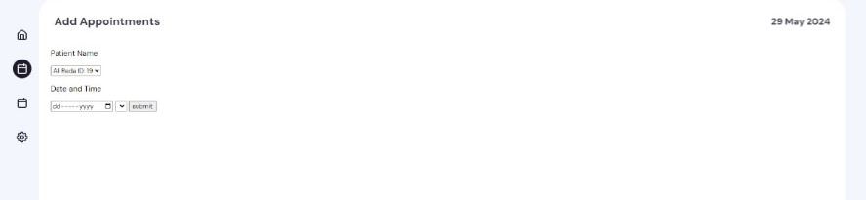

*Figure 23 – Add appointment*



*Figure 22 – select patient name*



*Figure 24- select date and time*

4.2.7-add records:

This page the doctor will use to add patients medical recordsby selecting patients name adding a prescription and uploading the files. ( Figure 28 – add records **&** Figure 27 – patient name **&** Figure 26 – choose file)

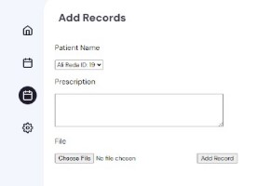

*Figure 28 – add records*

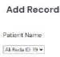

*Figure 27 –Patient name*

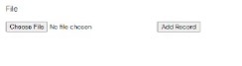 *Figure 26 – choose file*  4.2.8-doctors settings:

Settings page for doctor to update their information. (Figure 29 - settings)

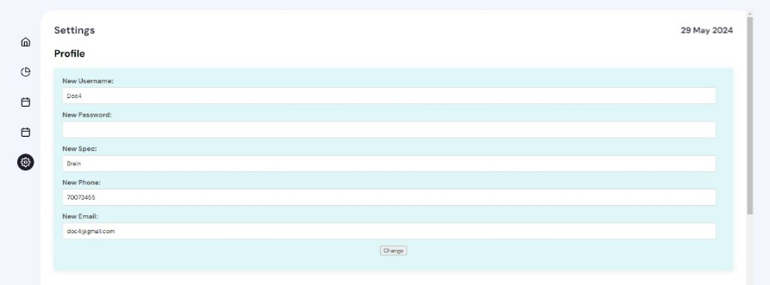

*Figure 29 - settings*

* + 1. add assistente/patient:

To add an assistant the doctor need to access the settings page the same way for patients . (Figure 30 - asistant **&** Figure 31 - patients)

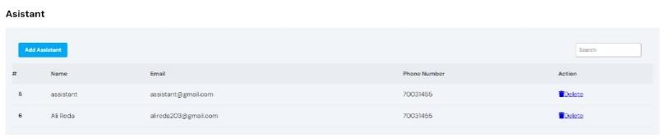 *Figure 30 - asistant*

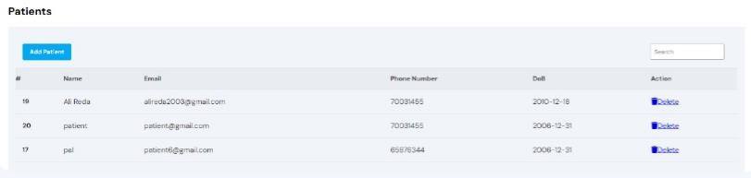

*Figure 31 - patients*

* + 1. admin page:

Admin profile page where admin can change the username and password for the account. (Figure 32 – admin prfile)

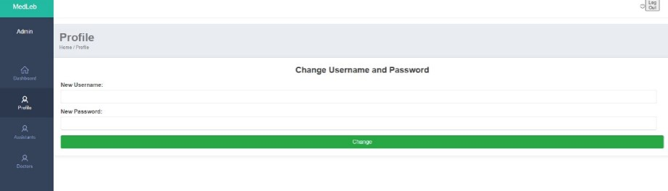

*Figure 32 – admin profile*

* + 1. admin add assistante:

Assistants can be added or removed within this page (Figure 33 assistans)

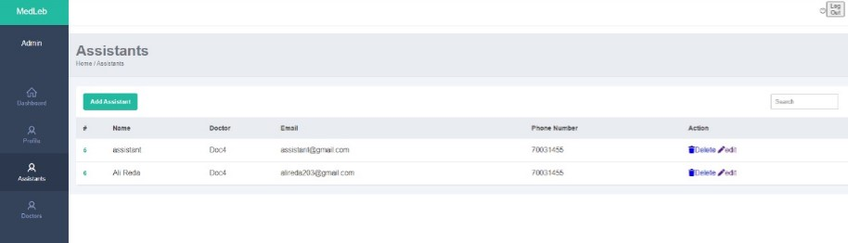

*Figure 33 - assistants*

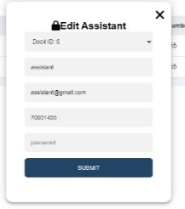

* + 1. admin add doctor:

Doctors can be modified and remove or added within this page by clicking add doctors new doctors can be added and by clicking delete doctors will be deleted. (Figure 34 – edit doctors **&** Figure 35 – add/delete)

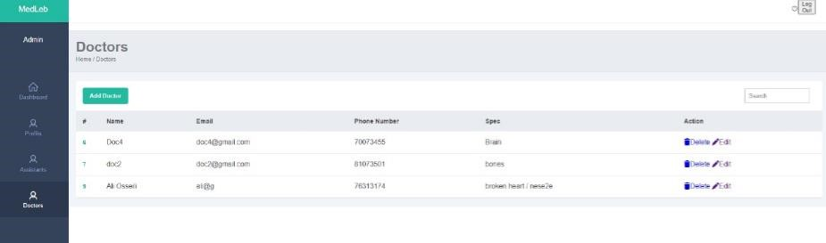

*Figure 34 – edit doctors*

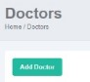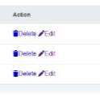

*Figure 35 – add/delete*

4.2.14- login / signup:

Login page to give the patient full accessibility to the page (Figure 37 - login **&** Figure 38 - signup)

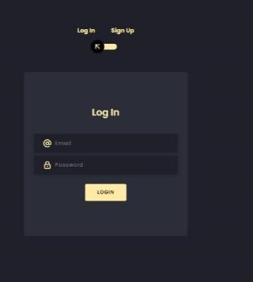

*Figure 37 - login*

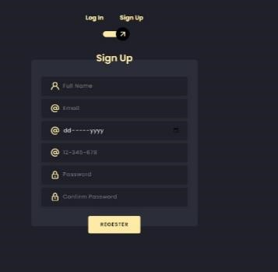

*Figure 38 - signup*

Chapter 5

* 1. Conclusion:

Our primary goal was to develop and implement an efficient Hospital Management System. Through meticulous research, we observed a growing preference for online healthcare solutions over conventional methods. Thus, our system endeavors to bridge this gap by offering a comprehensive digital platform that keeps healthcare facilities abreast of contemporary trends and technological advancements.

* 1. Future Work:

Future work for our website would be to add a SOS page where if a patient was in critical state they can send an sos and the nearest ambulance will rush for help, the second idea is to add community groups where patients with identical illnesses can chat as well as doctors and patients.

References

Developers, W. (n.d.). *W3 Schools*. Retrieved from w3schools.com: https://www.w3schools.com/ *github*.

(n.d.). Retrieved from github.com: https://github.com/ *stackoverflow*. (n.d.). Retrieved from stackoverflow.com: https://stackoverflow.com/